FABRICATION LAB

EXPERIMENT: 2

Thermal Oxidation of Cleaned Wafer

Sounak Mandal

19EC10088

Aim

The aims of the experiment are:

1. To perform thermal oxidation on the surface of clean silicon wafer.
2. To measure the thickness of the produced oxide layer

Introduction

Silicon naturally forms native oxide layer on exposure to air. But this oxide layer is not uniform and moreover, not free of impurities. This is the reason the cleaning steps used buffered HF to etch out the native oxide. Controlled oxidation is used to form a layer of uniform thickness which is free of impurities.

Apparatus Used

1. Quartz boat and carrier
2. Quartz rod
3. Tweezers
4. Horizontal or vertical furnace
5. Heat barrier
6. Bubbler

Chemicals Used

1. Nitrogen (N2)
2. Oxygen (O2)
3. Water (H2O)

Importance of Silicon Dioxide

Silicon Dioxide is very important in fabrication of semiconductor devices because it has widespread uses in the following places:

1. The high performance of modern MOS capacitor requires ultra-thin silicon dioxide for the gate dielectric layer.
2. It helps in insulating one device from another, specially when many such devices are fabricated on a single semiconductor block.
3. It provides surface passivation that ties up the dangling bonds at the surface of semiconductor devices and prevents further chemical reaction, since it is relatively inert.
4. It can be used as a mask against implantation of dopant atoms by diffusion, deposition or sputtering.
5. It provides insulation in case of multi-level metallization systems.

Furnace

The most commonly used type of furnace is three-stack three-zone horizontal diffusion furnace. There are three oxidation chambers each of which has three zones.

The entire tube is made of quartz. The segregation of the tube into three zones is done on the basis of position of resistive heating coil. The distribution of temperature in three zones is a Gaussian distribution. The quartz boat with wafers is placed in the central zone.

Quartz apparatus are present to hold wafers and close lid of furnace at entry point. There are various controller valves to control the flow of N2 to make the tube inert, and O2 for carrying out controlled oxidation.

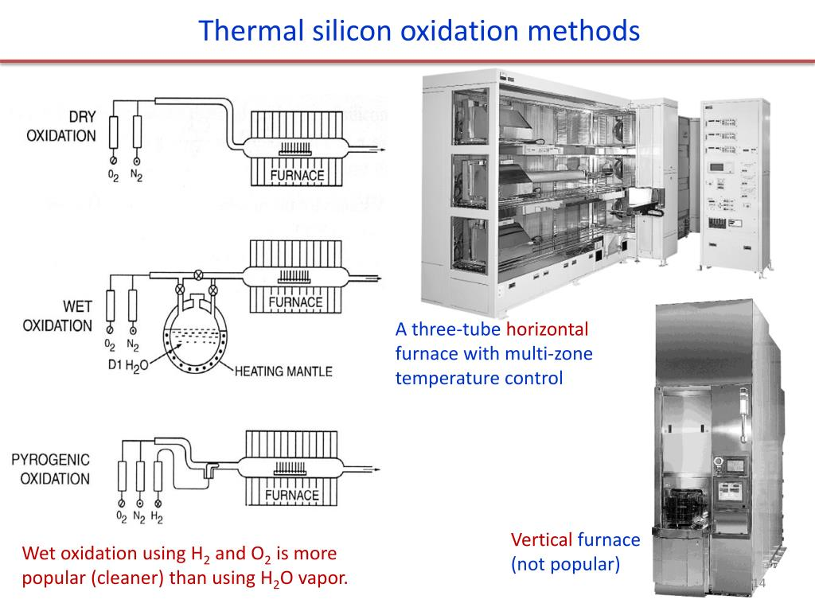

Thermal Oxidation

Thermal oxidation of silicon results in increase in volume since SiO2 is less dense than Si but also heavier. The reaction occurs at the surface and SiO2 is deposited at the interface, consuming Si from bulk.

$$\frac{Thickness of Si}{Thickness of {SiO}_{2}}=\frac{Molar volume of Si}{Molar volume of {SiO}_{2}}=$$

$$\frac{{Molecular Weight(Si)}/{Density (Si)}}{{Molecular Weight ({SiO}_{2})}/{Density ({SiO}_{2})}}=\frac{\frac{28.08 g/mol}{2.33 g/{cm}^{3}}}{\frac{60.08 g/mol}{2.21 g/{cm}^{3}}}=0.44$$

If thickness of SiO2 layer formed is t, then 0.44t is the thickness formed below original surface and 0.56t is formed above the original surface.

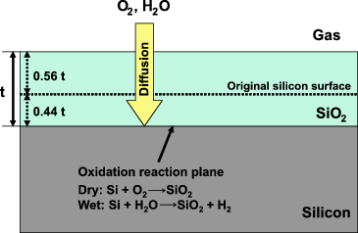

The process is heavily influenced by the following parameters:

1. The type of oxidant species.
2. The temperature and moisture content used during the reaction.
3. The crystal orientation of the substrate.

These parameters enable us to perform two distinct types of oxidation reactions which differ in time required for oxidation for fixed oxide thickness, quality of oxide and maximum oxide thickness that can be formed.

Dry Oxidation

The atmosphere is free of moisture, oxygen acts as oxidising agent. The growth rate of silicon is about 5-33 Å/min but the quality of oxide is excellent. The maximum oxide thickness is about 500 nm.

$$Si(solid)+ O_{2}(gas) → {SiO}_{2}(solid)$$

Wet Oxidation

Water vapour acts as oxidising agent. The growth rate of layer is much faster 25-220 Å/min but the quality is moderate. The maximum oxide thickness is about 2000 nm.

$$Si\left(solid\right)+{2H}_{2}O\left(vapour\right)→ SiO_{2}\left(solid\right)+ 2H_{2}(gas)$$

Procedure

The procedure for conducting thermal oxidation in a furnace is:

1. The furnace is heated to a temperature of about 550°C with N2 flow at 2 slm. N2 is constantly made to flow during the process for maintaining an inert atmosphere.
2. The wafers from desiccator are placed on a quartz boat which is slowly loaded in the centre zone of the furnace tube with the help of quartz carrier and quartz rod. After placing the quartz boat the quartz carrier is pulled out with the help of quartz rod and the door to furnace is closed.
3. The temperature of the furnace is set at 1050°C with a ramp of 10°C/min.
4. The entire oxidation is divided into three parts - dry, wet and dry. The duration for each is 10min, 5 min and 10 min respectively.
5. In the first dry oxidation, O2 gas is passed into the furnace at 2 slm for 10 minutes.
6. For the next part of wet oxidation, H2O vapour from bubbler is allowed for 5 min at 1 slm to rapidly form a thick layer of oxide.
7. Finally, the second dry oxidation for thin, high quality oxide layer finish is done. O2 gas is passed into the furnace at 2 slm for 10 minutes.
8. The temperature of the furnace is cooled down to 550°C with a ramp down of 10°C/min. When this temperature is achieved N2 flow is stopped.
9. When the furnace cools down to room temperature, the wafers in quartz boat is taken out and kept in ultra-clean container for further processing.

Deal-Grove model

This is the mathematical model for growth of oxide on the surface of any material. This model assumes that the reaction occurs between the oxide and the substrate. The process of oxidation is assumed to happen in three steps:

1. The oxidising species diffuses to the surface of the oxide.
2. It diffuses through the existing oxide layer to reach the oxide-substrate interface.
3. The actual reaction occurs at this interface. In case of silicon wafers, the chemical reaction converts silicon (Si) to silicon dioxide (SiO2).

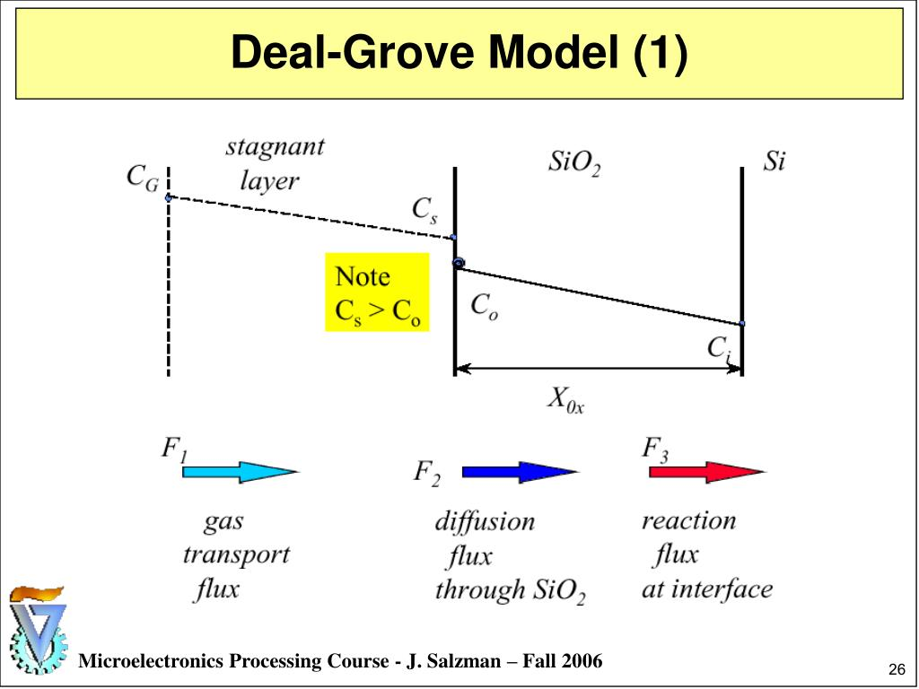

The model assumes that each of the stages proceeds at a rate that is proportional to the concentration of the oxidant.

$$J_{gas}(F_{1})= h_{g}(C_{G}-C_{s})$$

$$J_{oxide}(F_{2})= D_{ox}\frac{C_{o}-C_{i}}{x}$$

$$J_{react}(F_{3})= k_{i}C_{i}$$

The steady state condition is reached when the flux of oxidant in the ambient gas, oxide layer and semiconductor bulk are equal. These assumptions help in calculating the growth rate of oxide as a function of time.

$$t_{ox}(t)=\frac{A}{2}\left(\sqrt{1+\frac{4B(t + τ)}{A^{2}}}-1\right)$$

1. $A$ and $B$ encapsulate the properties of the reaction, diffusion through oxide and diffusion through gas.
$$A=2D_{ox}\left(\frac{1}{k_{i}}+\frac{1}{h_{g}}\right)$$

$$B= \frac{2D_{ox}C_{s}}{N}$$

2. $τ$ is obtained from the initial conditions of oxide thickness.

$$τ= \frac{t_{ox,i}^{2}+At_{ox,i}}{B}$$

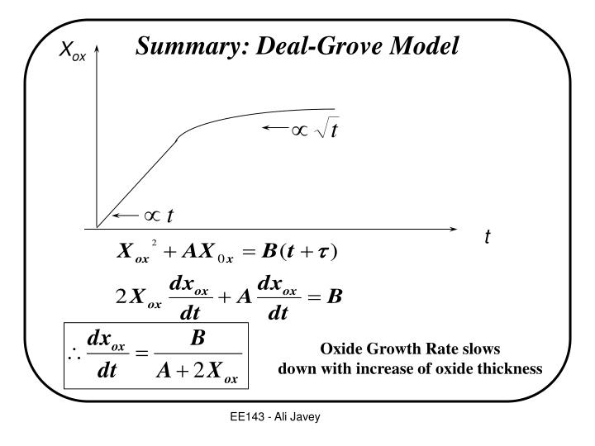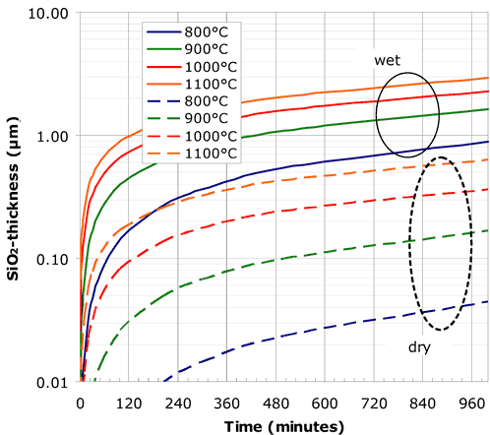

Observation

1. Before oxidation the wafer is shiny and silvery. After oxidation it has a bluish tint due to presence of oxide layer which diffracts light.
2. The formation of oxide is from top to down. After an oxide layer has been formed, the oxidant diffuses through the oxide layer to the interface and the new layer of oxide is formed below the existing layer.
3. The Deal Grove model predicts that the rate of oxidation is linear at first and then after sufficient time, the dependence is actually square root dependence. Practically this happens as the oxide layer which thickens with time prevents diffusion of oxidant to the interface.
4. The growth rate is faster in <111> orientation than in <100> orientation.
5. After oxidising the surface, the oxide thickness can be measured using:
6. Colour chart
7. Ellipsometer
8. CV technique
9. Surface profilometry

Conclusion

1. Oxidation is carried out in dry-wet-dry fashion. Dry oxidation is for high quality oxide while wet oxidation is for faster growth.
2. 44% of silicon thickness is consumed for producing layer of some thickness.
3. After oxidation it is necessary to check the thickness of produced oxide using sophisticated techniques to determine whether the wafer is ready for further processing.